2.2 Triage of Massively Bleeding Patients – Corporate Hospital Policy
This is a hospital wide policy that should be part of your HEBMP, and complement any strategies, processes or policies developed by the hospital for other situations where triaging may be warranted. The policy should be developed by the hospital’s emergency blood management committee (HEBMC) or equivalent, in conjunction with other key hospital stakeholders, such as risk/emergency management and leadership.
Key elements of the plan may include:

Policy
During a period of critical blood component shortage, it may be necessary to withhold transfusion support for massively bleeding patients to maintain product availability for other individuals. As such decisions carry significant medical, legal, and ethical repercussions, therefore a designated triage team, operating under a defined framework, is required to perform this task of triaging patients requiring blood and blood products. The following information is in alignment with the National Advisory Committee on Blood and Blood Products - Emergency Framework for Rationing of Blood for Massively Bleeding Patients during a Red Phase of a Blood Shortage document^{1,2}. Corporate hospital policies may already have a framework for triaging patients in critical shortages (e.g., respirators during COVID, critical drug shortages) and should be considered in addition to specific information outlined for blood component shortages.
A triage team including team leader should be identified by the hospital HEBMC to handle the complex and critical nature of adjudication, and it is recommended that the triage team be established in advance of a potential blood shortage. Depending on the size and scope of the hospital this multidisciplinary team may be comprised of the following administrative and clinical positions:
- Triage Team Leader. The triage team leader should be an experienced physician with familiarity in triaging critically ill patients, and broad-based knowledge of resources and capabilities of healthcare organizations. The triage team leader will have the final responsibility and authority over clinical decisions.
- A Management Representative. A management representative is required to provide guidance on the capability of the organization regarding resources, personnel, external support, and internal and external communications.
- An ethicist³.
- A nursing supervisor to provide direction on alternate care.
- Representative from the emergency room, trauma, transplantation, cardiovascular surgery, gastroenterology, and obstetrics to provide updates on demand, impact and assist in decision making.
- Palliative care nurse or physician for patients not triaged to receive blood.
- Social worker.
- Chaplain.
- Hospital Transfusion Service representative.
Identified core members of the triage team should have designates to ensure 24-hour availability. Team members should ensure that they are staying up to date with the following:
- Familiar with principles of patient triage and resource rationing frameworks during scarcity.
- Familiar with other corporate emergency hospital policies and the hospital emergency blood management plan.

Principles
The triage team should make patient-care decisions based on the following minimum principles:
- The team must remain separate from the direct clinical care of the patient.
- The team’s responsibility extends to all patients served by the Transfusion Service, not solely the individual patient under review.
- The team should be blinded to any patient-identifying information that is not essential to the triage decision.
- During a massive hemorrhage, an appeals process is not clinically feasible; therefore, the agreed-upon triage framework must be applied rapidly and decisively without an appeal mechanism.
- If transfusion support is withdrawn, all appropriate pain and symptom-management measures, as well as alternative care environments, must be made available as needed.
The triage team has the responsibility of providing a copy of the patient's triage record to the HTS at the end of each shift. HTS will provide this copy with patient identifiers to the patient care team, to ensure the documentation of the following adjudication elements in the patient’s record:
- Component and phase of blood shortage.
- Triage decision
- Reason for exclusion, if applicable
- Date/time of next planned re-evaluation
- Contact information from the triage team leader to provide a status update for the patient before the next re-assessment.
The triage team should have adequate administrative and psychological support services available to them.

Procedure
- Upon notification that the Hospital Emergency Blood Management Plan (HEBMP) has been activated in red phase blood shortage, the HEBMC should ensure that the triage team leader has contacted the other triage team members to confirm availability and, if unable to confirm, identify appropriate designate(s).
  - NEBMC will instruct hospitals when implementation is required of the Emergency Framework for Rationing of Blood for Massively Bleeding Patients during a Red Phase of a Blood Shortage.
- Upon notification from NEBMC, HTS will initiate hospital communication regarding implementation of triage in massively bleeding patients. (see toolkit memo)

- The Hospital Transfusion Service (HTS) will identify any patients experiencing or anticipated to need massive hemorrhage protocol activation and create an anonymized Patient Triage Record (section A) for each, populated with a unique tracking number, the cause of massive hemorrhage, and the date and time of triage.
- A corresponding triage tracking log (see toolkit), linking each patient’s identifiers with the unique tracking number documented on the Patient Triage Record, will be maintained by the HTS and not provided to the triage team, to maintain blinding.
- The triage team leader should convene a meeting of the triage team in a non-clinical service area of the hospital. Time and location of this meeting should be communicated to the HTS to ensure that the clinical team is aware of patient treatment adjudication by the triage team.
  - Contact information for the clinical team shall be provided to the triage team for information/updates on the clinical condition of the patient.
  - HEBMC/HTS or designate will provide the patient care team with the anonymized patient triage record number as well as patient identifiers, to enable communication between the triage team and patient care team regarding patient status and exclusion criteria, while maintaining blinding of patient identifiers to the triage team
- While maintaining blinding of patient identifiers, the triage team will need to determine if the patient being triaged meets any of the general exclusion criteria as outlined in the Emergency Framework for Rationing of Blood for Massively Bleeding Patients during a Red Phase of a Blood Shortage (see algorithm).
  - This information will be documented on the Patient Triage Record (section B).
  - At the end of each shift, or at least daily, a copy of these records is provided to HEBMC.
  - After completion of Red Phase, a copy of these records is provided to OEBMC.
- If No to all general exclusion criteria, the triage team will determine presence of any specific exclusion criteria, as outlined in the Emergency Framework for Rationing of Blood for Massively Bleeding Patients during a Red Phase of a Blood Shortage, from the following clinical categories:
(These criteria apply to adults and pediatrics patients unless otherwise specified)
  - Trauma (any of the following)
    - Non-survivable brain injury.
    - Glasgow Coma Scale = 3 with hypotension not attributable to reversible factors and with fixed and dilated pupils.
    - Declared brain death, for the purpose of deceased organ donation.
    - Penetrating cranial trauma and Glasgow Coma Scale = 3 not attributable to reversible factors.
    - Penetrating cranial trauma, Glasgow Coma Scale less than 8 not attributable to reversible factors, hypotension and severe thoracoabdominal trauma.
    - Blunt trauma and a Glasgow Coma Scale = 3 not attributable to reversible factors.
    - Blunt trauma with lost vital signs pre-hospitalization.
    - Transcranial gunshot injuries.
    - Age greater than 65 years with severe brain injury, profound shock, and severe thoracic or abdominal trauma.
    - Age greater than 75 years with moderate brain injury, a Glasgow Coma Scale less than 12, in profound shock, and with thoracoabdominal injury.
- Ruptured abdominal aortic aneurysm (any of the following):
  - Pre-operative cardiac arrest.
  - Systolic blood pressure is less than 70 mmHg, unresponsive to fluid resuscitation, and lost consciousness.
  - Does not meet criteria for emergent vascular repair.
- Extracorporeal membrane oxygenator (ECMO) / ventricular assist device (VAD)
  - Multi-organ (more than one organ) failure.
NOTE: Physicians, patients and families should be notified that they may not receive transfusion support if massively bleeding while on ECMO/VAD and having multi-organ failure, during a red phase shortage.
- Organ transplantation (any of the following):
  - Deceased donor organ recovery for transplantation should proceed, with the understanding that the deceased donor will not be transfused in the process of deceased donor stabilization.
  - Deceased donor solid organ transplants may proceed with informed consent regarding increased risk from restriction of blood transfusion, and with the understanding (among patient and all involved physicians) that blood may not be available for transfusion.
  - Living donor - recovery should be deferred until shortage has resolved.
- Gastroenterology (any of the following):
  - Gastrointestinal bleeding and a Rockall score greater than 8.
  - Liver cirrhosis and gastrointestinal (i.e. variceal) bleeding with Child-Pugh score greater than 10 (MELD score greater than 18) and not listed for transplantation.
- Obstetrics:
  - No exclusions (i.e. transfusion should not be withheld).
- Other situations:
  - Any patient for whom the triage team believes the mortality rate exceeds 80%.
- All triage team members must agree with the determination of general or specific exclusion criteria and decision on transfusion support. Members will sign the Patient Triage Record indicating agreement.
  - If in agreement that patient meets any of the general or specific exclusions criteria and that transfusion support is to be withheld, then the patient will be reassessed every 24 hours or earlier if the clinical team communicates that the patient’s condition has significantly improved and would qualify for transfusion support.
  - If in agreement that patient does not meet any of the general or specific exclusion criteria and that transfusion support will continue, then the patient will be reassessed after every 10th unit of RBC’s (or as directed by NEBMC) or every 24 hours for patients receiving less than 10 units of blood until cessation of hemorrhage.
- Forward signed Patient Triage Record to HTS. HTS keep one copy with triage tracking log and forward one copy to clinical care area for patient chart. Copy for patient chart may include identifying patient information (name, MRN) obtained from triage tracking log.
- HTS will notify the triage team at the time of 10th unit of RBC issued for patient reassessment.
  - For all subsequent meetings of the triage team, the HTS will provide original anonymized Patient Tracking Record(s) for that patient with any new information for the triage team to assess and document reassessment decisions.
- Triage team leader will reconvene the triage team at a minimum frequency of every 24 hours and/or as every triaged patient has received 10 units of RBCs.
  - HTS should be aware of all scheduled meetings to ensure that any newly identified patients requiring triage have a Patient Tracking Record completed for review by the triage team.
  - Reassessment decisions will be based on SOFA score (see appendix), total blood products used, need for ongoing transfusion support, and ability to control bleeding with surgical or medical procedures. Patients with a SOFA score >11, continued need for large amounts of blood components and no foreseeable ability to control blood loss will be triaged to palliative care.
  - Reassessment decisions by the triage team should be documented in section C of Patient Triage Record form.
- Continue steps 1-9 until NEBMC indicates that the blood shortage has improved, and implementation of the Emergency Framework for Rationing of Blood for Massively Bleeding Patients during a Red Phase of a Blood Shortage can be discontinued.
- HTS to forward all Patient Triage Records daily to HEBMC (or Hospital Transfusion Committee, as applicable) for review
  - HEBMC will review and record patient outcomes, to ensure ‘over triage’ and ‘under triage’ errors are minimized
  - Anonymized Patient Triage Records may be requested by the Ministry of Health / Ontario Emergency Blood Management Committee and should be submitted on request.

Limitations
In the event two or more massively bleeding patients requiring blood components at the same hospital both/all qualify for active transfusion management by the triage team, the following principles (in order) are suggested to prioritize transfusion resources:
- Administer blood to the youngest patients first (with the goal of maximizing the number of years of life saved).
- Administer blood to patients who have the highest likelihood of hemostasis control.
- Administer blood according to the first-come, first-served principle.
If two or more patients are competing for blood components at different hospitals and the blood still resides at the local blood centre, the same aforementioned principles will be applied jointly by the blood centre physician and the triage team leader from the hospitals involved.

Appendix

SOFA Score
The SOFA score as described by Vincent et al⁴.
SOFA score | 0 | 1 | 2 | 3 | 4
PaO2/FIO2 Ratio | >400 | <400 | <300 | <200 and mechanically vented | <100 and mechanically vented
Platelet Count | >150 | <150 | <100 | <50 | <20
Bilirubin (umol/L) | <20 | 20-32 | 33-101 | 102-204 | >204
Hypotension  (ug/kg/min) | None | MAP <70 | Dopamine <5 or dobutamine (any dose) | Dopamine >5 or epinephrine <0.1 or norepinephrine <0.1 | Dopamine >15 or epinephrine >0.1 or norepinephrine >0.1
Glasgow Coma Scale | 15 | 13-14 | 10-12 | 6-9 | <6
Creatinine (umol/L) | <110 | 110-170 | 171-299 | 300-440 or <500mL/day | >440 or <200mL/day

Decision Tree for triage team
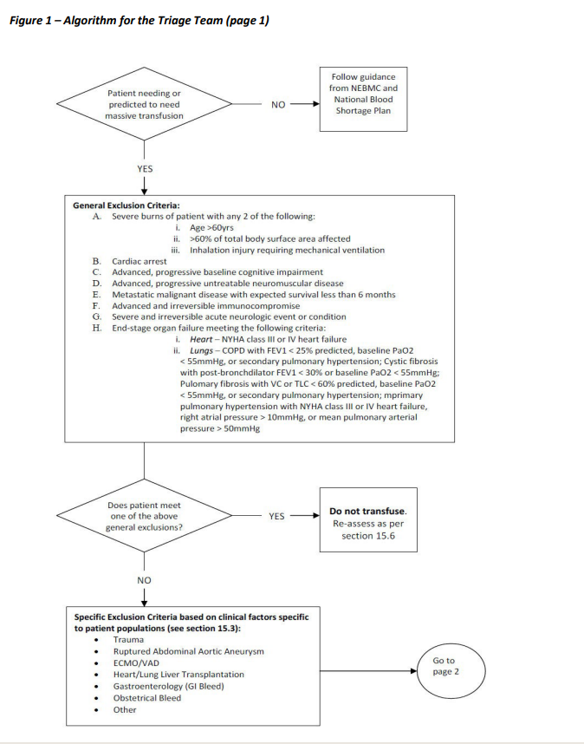

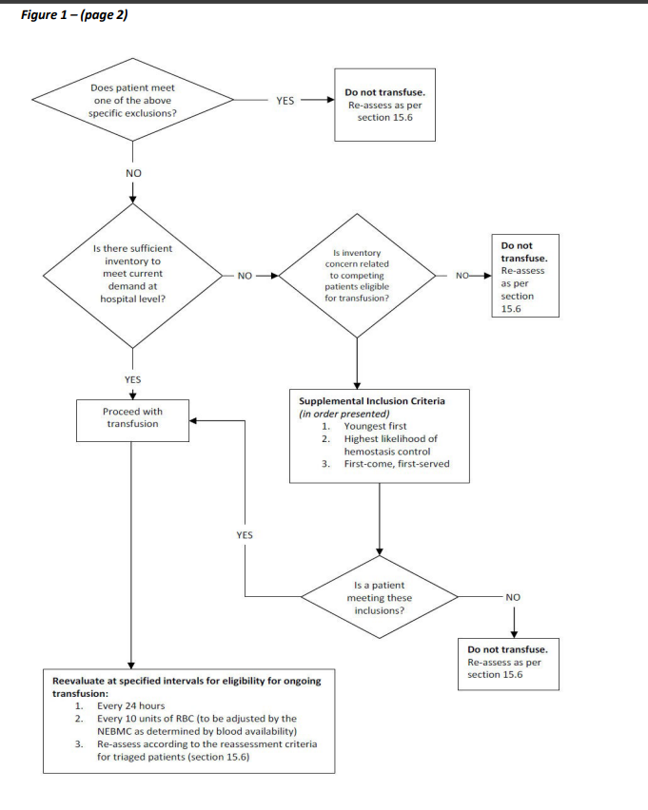

Sample Patient Triage Record
Section A: Completed by Hospital Transfusion Service
Date/time NEBMC invoked Emergency Framework for Triage of Massively Bleeding Patients:
Patient Tracking Number:
Age: | ABO/Rh group: | Additional antigen matching required:
Location: |  | Date/Time of Triage Assessment:
Cause of bleeding:
Most responsible physician at time of triage (name and contact info):
Has patient received product in the previous 24 hrs? |  | ☐ Yes | ☐ No
Predicted need more than 10 units in next 24 hrs? |  | ☐ Yes | ☐ No (refer to standard tracking tool)
Section B: Completed by the Triage Team
Does the patient have any of the following exclusion criteria?
General | Specific
- Severe burns with any two of the following:  • Age > 60 years  • >60% of body surface area affected  • Inhalation injury requiring mechanical ventilation  - Cardiac arrest  - Advanced, progressive baseline cognitive impairment  - Advanced, progressive, untreatable neuromuscular disease  - Metastatic malignant disease with expected survival less than 6 months  - Advanced and irreversible immunocompromise  - Severe and irreversible acute neurologic event or condition  - End-stage organ disease meeting the following criteria:  • Heart: NYHA class III or IV heart failure  • Lungs:  - COPD with FEV1 less than 25% predicted, baseline PaO2 less than 55 mmHg, or secondary pulmonary hypertension  - Cystic fibrosis with post-bronchodilator FEV1 less than 30% or baseline PaO2 less than 55 mmHg  - Pulmonary fibrosis with VC or TLC less than 60% predicted, baseline PaO2 less than 55 mmHg, or secondary pulmonary hypertension  - Primary pulmonary hypertension with NYHA class III or IV hear failure, right atrial pressure greater than 10 mmHg, or mean pulmonary arterial pressure greater than 50 mmHg | Trauma (any of the following):  - Non-survivable brain injury  - Glasgow Coma Scale = 3 with hypotension not attributable to reversible factors and with fixed and dilated pupils  - Declared brain death (for purpose of deceased organ donation)  - Penetrating cranial trauma and Glasgow coma scale = 3 not attributable to reversible factors  - Penetrating cranial trauma, Glasgow coma scale less than 8 not attributable to reversible factors, hypotension and severe thoracoabdominal trauma  - Blunt trauma and a Glasgow Coma Scale = 3 not attributable to reversible factors  - Blunt trauma and vital signs lost pre-hospitalization  - Transcranial gunshot injuries  - Age greater than 65 years with severe brain injury, profound shock and severe thoracic or abdominal trauma  - Age greater than 75 years with moderate brain injury, a Glasgow Coma scale of less than 12, in profound shock and with thoracoabdominal injury  Ruptured abdominal aortic aneurysm (any of the following):  - Pre-operative cardiac arrest  - Systolic blood pressure less than 70 mmHg, unresponsive to fluid resuscitation, and lost consciousness  - Does not meet criteria for emergent vascular repair  ECMO/VAD:  - Multi- organ (more than 1 organ) failure (patients and families to be notified that they may not receive transfusion support if massively bleeding)  Organ transplantation (any of the following):  - Deceased donor organ recovery for transplantation should proceed with the understanding that the deceased donor will not be transfused in the process of deceased donor stabilization.  - Deceased donor solid organ transplants may proceed with informed consent regarding increased risk from restriction of blood transfusion, and with the understanding (among patient and all involved physicians) that blood may not be available for transfusion.  - Living donor (recovery should be deferred until shortage has resolved)  Gastroenterology (any of the following):  - Gastrointestinal bleeding and a Rockall score greater than 8  - Liver cirrhosis and gastrointestinal (i.e. variceal) bleeding with Child-Pugh score greater than 10 (MELD score of greater than 18) and not listed for transplantation  Obstetrics:  - No exclusions (i.e. transfusion should not be withheld)  Other situations:  - Any patient whom the triage team believes the mortality rate exceeds 80%
Additional considerations or information pertinent to reassessment:

Final decision by triage team: | ☐ Continue transfusion support |  | ☐ Withdraw transfusion support
Patient to be reassessed | ☐ every 10th unit of RBC’s |  | ☐ every 24 hours (or as indicated)
Triage Physician Signatures (Every physician team member shall sign indicating agreement with patient assessment)
Name: |  | Signature:
Name: |  | Signature:
Name: |  | Signature:
Name: |  | Signature:
Name: |  | Signature:
Section C – To be completed by Triage Team at reassessment if still bleeding or rebleeding, every 10 units or at 24hr as applicable.
Date and Time of Reassessment  (YYYY/MM/DD 24:00) | Does patient meet specific exclusion criteria? | SOFA score (enter value) | Decision on Transfusion Support | Reassessment sign off by Triage Leader / designate, name and signature
 | ☐ No  ☐ Yes Specify: |  | ☐ Continue/start  ☐ Withhold
 | ☐ No  ☐ Yes Specify: |  | ☐ Continue/start  ☐ Withhold
 | ☐ No  ☐ Yes Specify: |  | ☐ Continue/start  ☐ Withhold
 | ☐ No  ☐ Yes Specify: |  | ☐ Continue/start  ☐ Withhold
 | ☐ No  ☐ Yes Specify: |  | ☐ Continue/start  ☐ Withhold
Reassessment comments:

Section D – To be completed by HEBMC or HTS
Patient outcome at 24 hours of cessation of hemorrhage / blood shortage
Patient outcome at discharge
Patient outcome at 6 months
Documentation forwarded to MOH / OEBMC | ☐Yes ☐ No | Date:

References
    - Emergency Framework for Rationing of Blood for Massively Bleeding Patients during a Red Phase of a Blood Shortage. Working Group on Emergency Disposition of Blood during a Red Phase Blood Shortage: National Advisory Committee on Blood and Blood Products; April 14, 2012.
    - Emergency framework for rationing of blood for massively bleeding patients during a red phase of a blood shortage – Synopsis for Triage Team. National Advisory Committee on Blood and Blood Products; October 11, 2012.​​
    - Strech D, Hurst S, Danis M. The role of ethics committees and ethics consultation in allocation decisions: A 4-stage process. Med Care. 2010 Sep;48(9):821-6.
    - Vincent JL, Moreno R, Takala J, Willatts S, De Mendonca A, Bruining H, et al. The SOFA (sepsis-related organ failure assessment) score to describe organ dysfunction/failure. On behalf of the working group on sepsis-related problems of the European society of intensive care medicine. Intensive Care Med. 1996 Jul;22(7):707-10.

Resources
Triage tool for the rationing of blood for massively bleeding patients during a severe national blood shortage: guidance from the National Blood Transfusion Committee. Doughty H, Green L, Callum J, Murphy MF; National Blood Transfusion Committee.Br J Haematol. 2020 May 20:10.1111/bjh.16736. doi: 10.1111/bjh.16736. Online ahead of print. PMID: 32436251

