- Principle

The use of a sterile connecting device (SCD) maintains the integrity of the blood component while allowing manipulation of the product.
Use of a SCD produces sterile welds between two compatible segments of tubing to create a closed system product allowing for shelf life of the component to remain unchanged.

- Scope and Related Policies

  - The sterile connecting device may only be used for approved procedures. ^{9.1}

  - Any requests for non-conforming uses must be approved by the Medical Chief or delegate. See QCA.020 Medical Director Consultation Protocol.^{9.1}

  - This procedure is based on the design of a Terumo connecting device.

  - Documentation shall include random sterility checks, lot numbers of disposables, tube weld quality control logs.^{9.1}

- Specimen – N/A

- Materials

Equipment: Sterile connecting device (SCD)

Supplies: Welding Wafers
Transfer pack

- Quality Control

  - Random sterility checks shall be performed on products on which the SCD has been used. ^{9.2}

  - Lot numbers, needles, welding wafers must be documented. ^{9.2}

  - Welded tubing must be visually checked for alignment. Figure 3-3 below. ^{9.2}
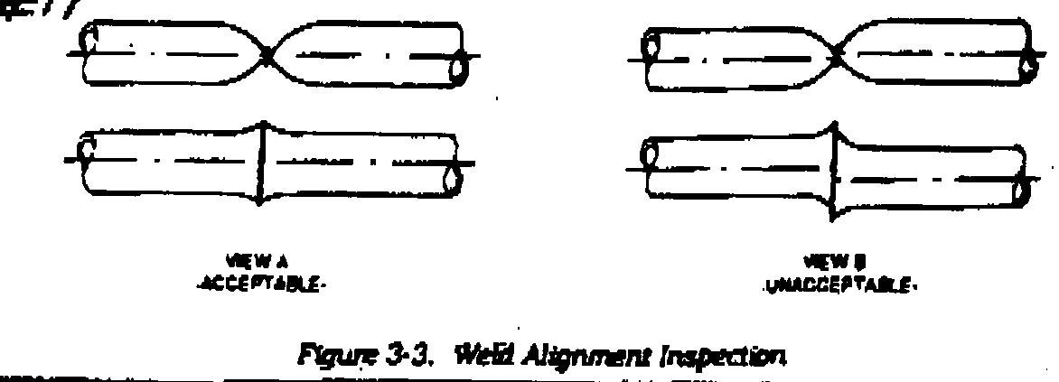

  - To open the tubing gently roll the tubing between your thumb and forefinger to open the tube. Do not pull on the seal, as this weld is not as strong as the original tubing. See Figure 3.2 below.
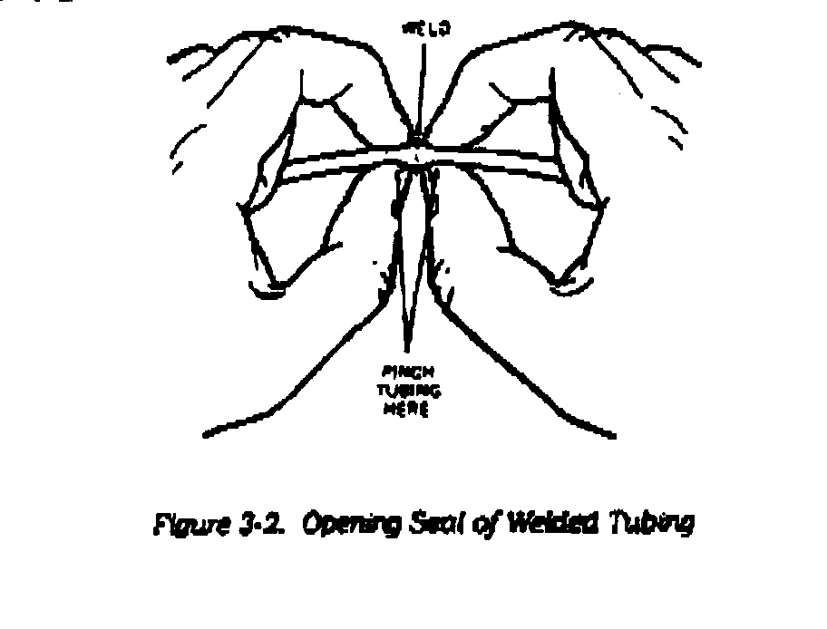
- Procedure

  - Turn the power switch ON (switch is on the back of the machine).
- Insert the wafer cartridge if one is not already in place. Record lot number. |  | - Make sure the wafer advance knob is positioned all the way to the back of the track.
 |  | - Position cartridge so that the writing is on top. Slide the cavity in the front of the cartridge onto the metal tab.
 |  | - Press the cartridge down until it snaps in place.
  - Open the tubing holder covers. Press the check button to ensure proper tube alignment and internal microprocessor check.

CAUTION: if the tubing from the last weld is not removed, a one-beep alarm will go off three seconds later.
  - Place the component bag of blood on the left-hand plate.
  - Press the tubing from the component bag of blood into the front tube holder, making sure the tubing is well seated in the bottom of the tube holder. Do not stretch it into place.
  - Place the transfer bag on the right hand plate.
  - Press the tubing from the transfer bag into the back tube holder, making sure the tubing is well seated in the bottom of the tube holder. Do not stretch it into place.
  - Make sure that at least 2 inches of tubing is used with at least one inch over the ends of the tube holder plates.
  - Close the left clamp first then the right one. It is important to follow this sequence to force the liquid out of the welding area and also for the proper internal checks by the machine.
  - Press button #1. This ensures that the tubing holders are closed and that the wafer cartridge is well installed. A one beep alarm will sound as the #1 button is pressed if the above conditions are not met by the operator. The red light will stay on until the cycle is completed.
  - Advance a new wafer by pushing the knob all the way forward then all the way back. Never reuse a wafer – chance of contamination or improper weld.
- Press button #2 to begin the process. Welding is done automatically by the machine. A red light will appear on the #2 button and will only turn off once the welding is complete and the weld has cooled. | - If one beep alarm is heard while pressing down, it means that a new wafer has not been loaded.
 | - If one beep alarm is heard one second after you press #2 button it means that the wafer is not properly positioned or the wafer is faulty. Repeat step 6.12.
 | - If one beep is heard 4 seconds after you press #2 button, it means that the wafer is faulty, the machine is being operated outside the acceptable temperature range (10C to 38C), or the machine has overheated from continuous use. Let it cool down with power on.
 | - If 3 beeps are heard, it means that you opened the tubing holder covers too soon.
  - Open lids.
  - Remove tubing stubs.
  - Remove the welded tubing and check its alignment visually. Carefully remove used wafer and dispose of it in a sharps container. If tubing is not properly aligned, discard the weld and repeat the process.
  - Gently roll the tubing between your thumb and forefinger to open the tube. Do not pull on the seal as this weld is not as strong as the original tubing.
  - Press the check button to realign the tube holders.
  - Clean the machine as needed with a damp cloth (use a weak bleach solution if necessary). Do not use solvents.

- Reporting – N/A

- Procedural Notes

  - If wafer alarm lamp lights, repeat from Procedure 6.4.

  - Tubing in near-side groove in left clamp is to connect with tubing in far-side groove in right clamp.

  - When connecting liquid-filled tubing with empty tubing, be sure to set liquid filled tubing in near-side grooves.

- References

  - Standards for Hospital Transfusion Services ver 3 February 2011. Canadian Society for Transfusion Medicine: 3.3.4.1; 3.3 4.2

  - Manufacturer’s directions for Terumo sterile connecting device.

- Revision History

Revision Date | Summary of Revision
September 1, 2014 | - Revised name of manual  - Added centrifugation requirements 6.3  - Removed reference to single units of platelets  - Updated all references to include the most recent version/edition and adjusted the page numbers cited as necessary

