IM.012-Shipment-of-Frozen-Blood-Components-Using-the-J82-Shipping-Container

PRINCIPLE
  - Most blood components and products are ordered directly by hospitals from Canadian Blood Services. Hospitals have the option of transferring blood components between facilities for optimal utilization or to ensure best patient care. In such cases, it is necessary to ensure that the blood components are properly packaged to maintain an acceptable temperature range during transportation, and the process ensures accurate tracking and disposition reporting.
  - Blood components or products being shipped for the purposes of redistribution, unless other agreements have been made:
- Frozen plasma should have between 4-6 months of shelf life prior to expiring
Cryoprecipitate should have between 3 months of shelf life prior to expiring

PURPOSE
To provide a standardized process for redistribution of frozen blood components to external sites using J82 shipping containers, so that the acceptable temperature range is maintained during transportation and ensure accurate tracking and disposition reporting. ^{10.1}

RELEVANT REQUIRMENTS

  - Blood components must be visually inspected for abnormal appearance immediately before packing for transportation. This inspection must be documented.^{10.1, 10.3}

  - Blood components must be transported in a validated shipping container and in a manner that will maintain the storage temperature requirements specified by the supplier. Shipment of frozen blood components shall ensure that the component remains in the frozen state.^{10.1} Compliance with these specifications is acknowledged by the signed Memorandum of Understanding on file with ORBCoN/FCRP.

  - Shipping containers for blood components must be constructed to resist damage, examined for damage prior to use and must be designed to include a tamper-proof seal.^{10.1, 10.4}

  - Shipping containers shall have an outer label that meets provincial, territorial or federal transport regulations and identifies: ^{10.1, 10.2}
- The shipping and receiving facility
- That the contents are human blood components
- Any other cautions or descriptions

  - All shipments of blood components and plasm protein and related products must include the following information on shipping packing slip or issue voucher/form: ^{10.1, 10.2}
- Name of shipping facility and receiving facility
- Identification of components shipped (unit numbers)
- Description of components
- Total number of units shipped
- Date and time shipped
- Identity and signature of the person who packed the shipment
- A unique shipping document number to allow for traceability
- Indication if blood component is not intended for transfusion (e.g., sending for research purposes)
- Indication if the blood component or plasma protein or related product is quarantined (if applicable).

  - All copies of shipping documentation must be retained according to requirements and/or facility policy, whichever is longest in order to maintain traceability of blood components and plasma protein and related products from their source until final disposition.^{10.3}

RELATED POLICIES/PROCEDURES (POLICIES IN OTTRM)
  - Glossary of Terms and Abbreviations
  - IM.003 - Visual Inspection of Blood Components and Plasma Protein and Related Products

MATERIALS
- Specimen – N/A
- Equipment
Approved and validated shipping container
If shipping | Then use | And these materials
Frozen Components (plasma or cryoprecipitate) | J82 Shipping Container  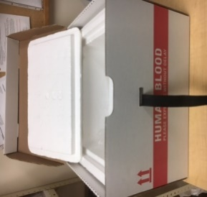 | - Dry ice  - Bubble sleeve or wrap  - Clear plastic over-wrap bag  - Clean crumpled paper  - Tamper-proof seal  - Purolator Healthcare Indicator label(if applicable)

- Reagents – N/A
- Supplies/Related Forms
- IM.006F1 Inter-hospital Redistribution Form
- IM.006F2 Shipping Address Label
- Waybill (if required)
- Annual Shipping Container Temperature Verification Report

QUALITY CONTROL
  - Periodic verification of the shipping container shall be performed to confirm that frozen components remain in a frozen state during shipment under the local conditions.^{10.1} Refer to ORBCoN’s Annual Shipping Container Temperature Verification Report.

  - Shipping containers must be inspected before and after each use. Check that:
- The inner container is clean and free of breaks or cracks
- The straps and buckles are in good condition
- The outer container is free of breaks/rips
- Address labels from previous shipments have been removed
- Gel and ice packs are not cracked or leaking
Note: Discard any materials deemed unacceptable for use and inform supervisor.

  - The required shipping temperatures for blood components are as follows: ^{10.1, 10.2}
PRODUCT | TEMPERATURE
Frozen Plasma | Maintain frozen state
Frozen Cryoprecipitate | Maintain frozen state

PROCEDURE
STEPS | WORK INSTRUCTIONS
- Obtain Dry Ice | Note: If the maintenance of minimum inventory depends on the arrival of replacement products from the blood supplier, avoid shipping “near to expire” products until the new shipment has been received.
 | - Contact supplier of dry ice a few days prior to shipping day to make arrangements to have a container with dry ice delivered to your facility.
- Inform Receiving Site | - Telephone and/or fax the receiving site (at least one day prior) to advise on the number and ABO group of units being shipped and the approximate expected arrival time. (If the shipment is urgent, notify the receiving facility as soon as possible.)
- Prepare Shipping Container | - Retrieve shipping container and all required supplies. Refer to section 5.2. See Procedure Note 9.1.  - Examine the shipping container to be used. See section 6.2.  - Prepare the shipping container no more than 1 hour before scheduled pickup time to ensure that components remain in a frozen state for the duration of the shipment.  - Cover the bottom of the shipping container with dry ice.  NOTE: Wear protective gloves when touching the dry ice. Dry ice is damaging if it comes into contact with skin.  - Place plastic bag into shipping container.
- Pack Components and Complete Documentation | - Obtain the blood components to be shipped from the freezer.  - Perform a visual inspection of the products. See IM.003 - Visual Inspection of Blood Components and Plasma Protein and Related Products  - Follow facility specific instructions for documenting the redistribution or transfer of blood components plasma protein and related products in the lab information system (LIS) or manual system. See Procedural Note 9.2.  - Complete Section A and B of Form IM 006F1.  - Make a copy of the completed form.  - Retain the copy in the laboratory for specified amount of time according to facility specific documents and record retention policy.  - Place frozen component(s) in bubble sleeve or bubble wrap (if available)  - Place the frozen components in the plastic overwrap bag on top of the dry ice  - Place temperature monitoring device inside the container prior to closing. (If applicable)  - Remove excess air from the plastic bag and close it. (Tie or fold the bag)  - Add more dry ice (gently) and ensure that all components are covered  - Fill any dead air space with loosely crumpled paper to reduce the likelihood of movement, and to ensure cool air can still circulate within the container  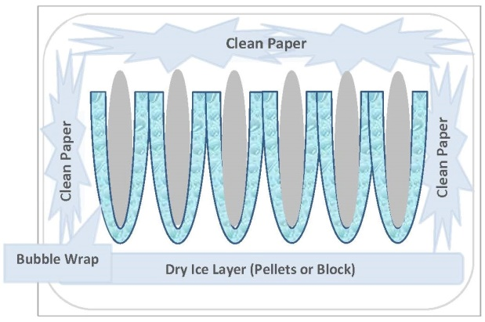  - Close lid of the inside Styrofoam box  - Place original form IM006F1 on top of Styrofoam lid in an envelope (secure with tape to ensure no slippage during transport)  - Close the outer cardboard container and fasten the strap securely  - *IMPORTANT* Apply the tamper-proof seal around the buckle of the strap so that the box cannot be opened unless the seal is removed.
- Prepare for Pick Up | - Place shipping container with completed documents in designated courier pick-up area where courier can retrieve it easily.  - Reconfirm the security seal/device is visible and intact.  - Notify courier that shipment is ready for pick up.

Reporting: N/A

PROCEDURE NOTES:
  - Where applicable, confirm with the courier that the shipping container will be transported inside the cab of the vehicle to ensure the container will not be exposed to extreme temperatures.
  - The shipping facility is responsible for the final disposition of blood components and plasma protein and related products in their LIS and reporting to CBS for items that have been wasted in transit.
  - Record of the storage temperature of the blood components and plasma protein and related products must be available on request. See IM006/IM007

  - REFERENCES:

  - CSTM Standards for Hospital Transfusion Services v5 December 2022. CSTM. Markham; 2022; 5.7.1
  - CAN/CSA-Z902:20 National Standard of Blood and Blood Components; 9.5 March 2020. CSA Group Toronto ON
  - Blood Regulation SOR/2013-178. Minister of Justice; August 25 2020, http://laws-lois.jstice.gc.ca
  - IQMH (Accreditation Canada Diagnostics) Medical Laboratory Accreditation Requirements v8 Dec 2019.

REVISION HISTORY
Revision Date | Summary of Revision
2021-04-30 | - Updated references  - Added procedural note 8.4
2021-08-20 | - Updated references  - Addition of Principle, Purpose and Related Policies and Procedures sections  - Sections renumbered & formatted
March 2023 | N/A

