Purpose:

To provide a standardized process for shipping frozen blood components to external sites using J82 shipping containers for the purpose of redistribution
To ensure that the acceptable temperature range is maintained during transportation and ensure accurate tracking and disposition reporting.^{9.1}

- Scope and Related Policies

  - Red blood cells and plasma/cryoprecipitate shall be packed in separate shipping containers for redistribution.

  - Blood components must be visually inspected for abnormal appearance immediately before packing for transportation. This inspection must be documented.^{9.1}

  - Blood components must be transported in a manner that will maintain the storage temperature requirements specified by the supplier in a validated shipping container. Shipment of frozen blood components shall ensure that the component remains in the frozen state.^{9.1,} Compliance with these specifications is acknowledged by the signed Memorandum of Understanding on file with ORBCoN.
  - Records of the storage temperature of the shipped components must be available on request.

  - Shipping containers for blood components must be constructed to resist damage and must be designed to include a tamper evident seal and examined for damage prior to use.^{9.1}

  - Shipping containers shall have an outer label that meets provincial, territorial or federal transport regulations and identifies: ^{9.1}
    - The shipping and receiving facility
    - That the contents are human blood components
    - Any other cautions or descriptions

  - Document all shipments of blood components to include the following information on shipping packing slip or issue voucher/form: ^{9.1}
- Shipping facility and receiving facility
- Identification of components shipped (unit numbers) and description of components and total number of units shipped
- Date and time shipped
- Identity and signature of the person who packed shipment
- A unique shipping document number to allow for traceability
- Indication if blood component is not intended for transfusion (e.g. sending for research purposes)

  - Shipment of blood components for the purpose of redistribution must include use of form IM.006F1 Inter-hospital Redistribution Form and appropriate Laboratory Information System transfer voucher (if applicable)
  - All copies of shipping documentation must be retained according to facility policy.

- Records/Forms/Documents:
- IM.006F1 Inter-hospital Redistribution Form
- Way bill (if required)
- IM.006F2 Shipping Address Label

- Materials
Equipment: Approved and validated shipping container
If shipping | Then use | And these materials
Frozen Components (plasma or cryoprecipitate) | J82 Shipping Container  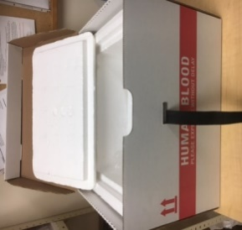 | - Dry ice  - Bubble sleeve or wrap  - Clear plastic over-wrap bag  - Clean crumpled paper  - Tamper proof device

- Quality Control
  - Periodic assessment of the shipping container shall be performed to confirm that frozen components remain in a frozen state during shipment under the local conditions.

  - Shipping containers must be inspected before and after each use.
Check that:
  - The inner container is clean and free of breaks or cracks
  - The straps and buckles are in good condition
  - The outer container is free of breaks/rips
  - Address labels from previous shipments have been removed
Note: Discard any containers or materials that do not pass visual inspection and inform supervisor

  - The required shipping temperatures for blood components are as follows: ^{9.1, 9.2}

PRODUCT | TEMPERATURE
Frozen Plasma | Maintain frozen state
Cryoprecipitate | Maintain frozen state

- Procedure

- Obtain Dry Ice | - Contact supplier of dry ice a few days prior to shipping day to make arrangements to have a container with dry ice delivered to your facility.
- Inform Receiving Site | - Telephone and/or fax the receiving site (at least one day prior) to advise on the number and ABO group of units being shipped and the approximate expected arrival time. (If the shipment is urgent, notify the receiving facility as soon as possible.)  - Note: If the maintenance of minimum inventory depends on the arrival of replacement components from the blood supplier, avoid shipping “near to expire” components until the new shipment has been received.
- Prepare Shipping Container | - Retrieve shipping container and all required supplies for selected shipping container  - Examine the shipping container to be used.  Do not use if:  □ the Styrofoam liner is not clean  □ the Styrofoam liner shows cracks or breaks  □ the straps or buckles are not in good workable condition  □ the outer cardboard box shows breaks or tears  Discard defective containers/materials as appropriate.  - Ensure all old address labels from the outside of the shipping container are removed or covered.  - Prepare the shipping container no more than 1 hour before scheduled pickup time to ensure that components remain in a frozen state for the duration of the shipment.  - Place plastic bag into shipping container  - Cover the bottom of the shipping container with dry ice.
- Prepare and Pack Components | - Remove identified components to be shipped from storage device/location.  - Place frozen component(s) in bubble sleeve or bubble wrap (if available)  - Place the frozen components in the plastic overwrap bag on top of the dry ice  - Remove excess air from the plastic bag and close it. (Tie or fold the bag)  - Add more dry ice (gently) and ensure that all components are covered  - Fill any dead air space with loosely crumpled paper to reduce the likelihood of movement, and to ensure that cool air can still circulate within the container  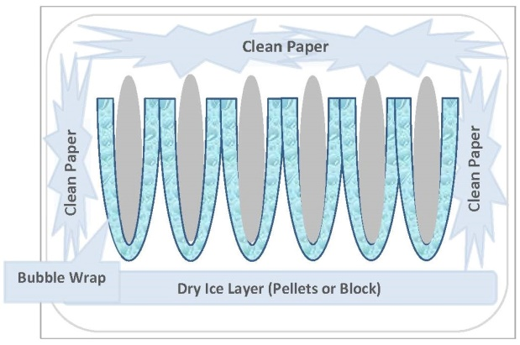  - Close lid of the inside Styrofoam box
- Review Documentation | - Follow facility specific instructions for documenting the transfer of products in the lab information system (LIS) or manual system  - Complete Section A and B of Form IM.006F1 and copy  - Retain copy in laboratory for specified amount of time according to documents and records retention policy.  - Place original form on top of Styrofoam lid in an envelope (secure with tape to ensure no slippage during transport)  - Ensure that all necessary information has been completed on the appropriate shipping label form IM.006F2  - Place completed shipping label inside the plastic sleeve located at the top of the shipping container  - Close the outer cardboard container and fasten the strap securely  - Apply the security device/seal * IMPORTANT*
- Prepare for Pick Up | - Place shipping container with completed documents where courier can retrieve easily.  - Reconfirm the security seal/device is visible and intact.  - Notify courier that shipment is ready for pick up.
- Receiving redistributed products | - Receiving facility reviews the form IM.006F1 and reconfirms components were received in the frozen state, expiry date of components received, and that the components were delivered to the correct facility  - Follow facility specific procedure for receiving components into inventory  - Receiving facility will confirm receipt with shipping facility by either faxing the completed IM 006F1 form back to the shipping facility using the number provided by shipping site or sending confirmation email to designated contact.

- Reporting

  - For components being transferred for redistribution use the Inter-hospital Redistribution Form (IM.006F1) and LIS voucher (if applicable)
Prior to shipping, a photocopy should be made of the completed form.

    - The original copy is sent with the shipping container to the receiving hospital
    - One copy is retained by the shipping hospital as per document retention requirements.^{9.1}

- Procedural Notes

- Confirm with the courier that the shipping container will be transported inside the cab of the vehicle to ensure the container will not be exposed to extreme temperatures.
- If the temperature check on receipt of transferred product is outside of the acceptable shipping range for the component or if the correct packing configuration is not followed, place the component(s) in quarantine and inform supervisor.
- If sites precondition the ice packs at warmer temperatures than stated in step 6.1.1, then those sites will need to perform their own validation to show that the containers can maintain acceptable temperatures for an established duration of time and provide the results to those sites that may receive the containers with products inside. Refer to Redistribution Toolkit section 5
- If shipping container or packing materials do not pass visual inspection they should be discarded.
- If components are being shipped for the purposes of redistribution, unless other agreements have been made:
    - Frozen plasma should have at least 3 months of shelf life left prior to expiry
    - Platelets should have between 12 and 24 hours of shelf life left prior to expiry

- References

  - CSTM Standards for Hospital Transfusion Services Version 4, Ottawa, ON: Canadian Society for Transfusion Medicine, April 2018: 5.7.1

  - Canadian Standards Association Blood and Blood Components Z902-20; 9.5 March 2020. CSA Group Toronto ON

  - Institute for Quality Management in Healthcare (IQMH) Medical Laboratory Accreditation Requirements. Version 8.0, Dec 2019; VI.2 IQMH is now Accreditation Canada Diagnostics

- Revision History

Revision Date | Summary of Revision
2021-04-30 | - Updated references  - Added procedural note 8.4

