Purpose:

To provide a standardized process for shipping blood components to external sites using J82/E38 shipping containers. This includes transfer for:
- Redistribution
- Provision of crossmatched units

To ensure that the acceptable temperature range is maintained during transportation and ensure accurate tracking and disposition reporting.^{9.1}

- Scope and Related Policies

  - Red blood cells and platelets must be packed in separate shipping containers for redistribution.

  - Blood components must be visually inspected for abnormal appearance immediately before packing for transportation. This inspection must be documented.^{9.1}

  - Blood components must be transported in a validated shipping container in a manner that will maintain the storage temperature requirements specified by the supplier.^{9.1,} Compliance with these specifications is acknowledged by the signed Memorandum of Understanding on file with ORBCoN / FCRP.

    - Discontinuation of agitation of platelets during transportation should not exceed 24hrs. ^{9.1}
  - Records of the storage temperature of the components must be available on request.

  - Shipping containers for blood components must be constructed to resist damage and must be designed to include a tamper evident seal and examined for damage prior to use.^{9.1}

  - Shipping containers shall have an outer label that meets provincial, territorial or federal transport regulations and identifies: ^{9.1}
    - The shipping and receiving facility
    - That the contents are human blood components or blood products
    - Any other cautions or descriptions

  - Document all shipments of blood components to include the following information on the shipping packing slip or issue voucher/form: ^{9.1}
- Shipping facility and receiving facility
- Identification of components shipped (unit numbers) and description of component/product and total number of units shipped
- Date and time shipped
- Identity and signature of the person who packed the shipment
- A unique shipping document number to allow for traceability
- Indication if the blood component is not intended for transfusion (e.g. sending for research purposes)

  - Shipment of blood components for the purpose of redistribution must include use of form IM.006F1 Inter-hospital Redistribution Form and appropriate Laboratory Information System (LIS) transfer voucher (if applicable)
  - All copies of shipping documentation must be retained according to facility policy.^{9.1}

- Records/Forms/Documents:
- IM.006F1 Inter-hospital Redistribution Form
- Way bill (if required)
- IM.006F2 Shipping Address Label

- Materials
Equipment:

Approved and validated shipping containers
If shipping | Then use | And these materials
RBC | J82 Shipping Container  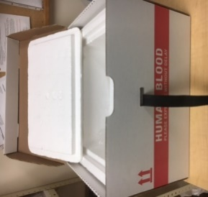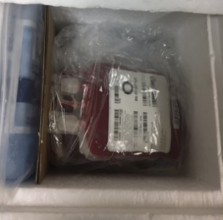 | - 1x ice pack  (8”w x8”h x1.5”d)  - 2x 4lb gel packs (10.5”w x 9.5”h)  - Plastic zip lock bags for gel and ice packs  - 2x Corrugated cardboard dividers (7.5”w x 7.5”h)  - Clear plastic over-wrap bag for product  - Clean crumpled paper  - Tamper proof device
PLT | E38 Shipping Container  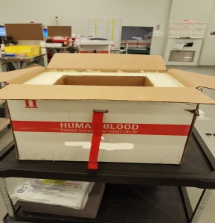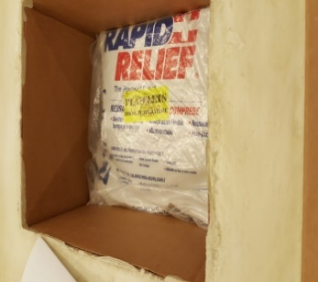 | - 3x 4lb gel packs (10.5”w x 9.5”h)  - Plastic zip lock bags for gel packs  - Clear plastic over-wrap bag for product  - Clean crumpled paper  - Tamper proof device

- Quality Control
  - Periodic assessment of the shipping container shall be performed to confirm that temperatures remain consistent within the acceptable temperature range under the local conditions.

  - Temperature checks upon receipt can be performed as per facility policy. See Procedural Notes 8.2
  - Shipping containers must be inspected before and after each use.
Check that:

  - The inner container is clean and free of breaks or cracks
  - The straps and buckles are in good condition
  - The outer container is free of breaks/rips
  - Address labels from previous shipments have been removed
  - Gel and ice packs are not cracked or leaking
Note: Discard any materials deemed unacceptable for use and inform supervisor

  - The acceptable shipping temperatures for blood components are as follows: ^{9.1, 9.2}

PRODUCT | TEMPERATURE
Red Blood Cell Units | 1 - 10ºC (within 24 hours)
Platelets | 20 - 24ºC

- Procedure

- Pre-conditioning | for RBC for Platelets  Gel pack(s) Between 2ºC and 6ºC for at least 6 hrs. Between 20ºC and 24ºC for at least 6 hrs.  Ice pack(s) Between minus 25ºC and minus 40ºC for at least 6 hrs N/A  - Pre-condition gel pack(s) and/or ice pack(s).  Note: if freezer temperature is warmer, this procedure must be validated to ensure acceptable shipping temperatures will be maintained using ice packs pre-conditioned at warmer temperatures. See Procedural Notes 8.2.
- Inform Receiving Site | - Telephone and/or fax the receiving site (at least one day prior for redistribution) to advise on the number of units being shipped and the approximate arrival time.(If the shipment is urgent e.g. short expiry date, notify the receiving facility as soon as possible.)  Note: If the maintenance of minimum inventory depends on the arrival of products from the blood supplier, avoid shipping “near to expire” products until the new shipment has been received.
- Packaging the components for redistribution | - Determine the required shipping container to be used. Refer to section 4.0 - Materials. and to Appendix A or B – Packing Configurations  - Retrieve shipping container and all required supplies for selected shipping container  - Examine the shipping container to be used.  Do not use if :  □ the Styrofoam liner is not clean  □ the Styrofoam liner shows cracks or breaks  □ the straps or buckles are not in good workable condition  □ the outer cardboard box shows breaks or tears  □ gel or ice packs have cracks or leaks  Discard defective containers/materials as appropriate.  - Ensure all old address labels from the outside of the shipping container are removed or covered.  - Prepare the shipping container no more than 1 hour before scheduled pickup time to ensure that temperature remains within the acceptable range for the duration of the shipment.
- For Red Blood Cells | - Refer to the packing configuration Appendix A for the maximum number of units that can be placed in the shipping container. Do not overfill.
- For Platelets | - Refer to the packing configuration Appendix B for the maximum number of units that can be placed in the shipping container. Do not overfill.  - Label each shipping container with “Do Not Refrigerate – Keep at Room Temperature.”
- Prepare Components Intended to be Shipped | - Remove identified components to be shipped from storage device/location. See procedural notes 8.5.  - Place components in plastic overwrap bag and then into the shipping container. If not shipping immediately, place components back in approved storage device until ready to ship.
- Pack Components | - Pack components according to the appropriate packing configuration (Appendix A or B).  - Fill any dead air space with loosely crumpled paper to reduce the likelihood of movement, and to ensure that cool air can still circulate within the container.  - Close lid of the inside Styrofoam box.
- Review Documentation | - Follow facility specific instructions for documenting the transfer of products in the lab information system (LIS) or manual system.  - Complete Section A and B of Form IM006F1 and copy.  - Retain copy in laboratory for specified amount of time according to documents and record retention policy.  - Place original form on top of Styrofoam lid in an envelope (secure with tape to ensure no slippage during transport)  - Close the outer cardboard container and fasten the strap securely.  - Ensure that all necessary information has been completed on the appropriate shipping label form:  If shipping via then  Purolator - Complete IM006F2 - Check the shipping label created by Purolator for correct shipper information and receiver information - If shipping information is incorrect notify the person who arranged the shipment with Purolator to rectify.  all other couriers Complete IM006F2  - Insert the shipping label form inside the plastic pouch located on the outside of the shipping container.  If shipping via then  Purolator Place the completed IM006F2 form in first and add the Purolator shipping label on top inside the plastic pouch so that it is visible to courier to scan  All other couriers Place the completed IM006F2 form inside the plastic pouch so that the receiving address is visible to the courier.  - Apply the security device/seal * IMPORTANT*
- Prepare for Pick Up | - Place shipping container with completed documents where courier can retrieve easily.  - Reconfirm that the security seal/device is visible and intact.  - Notify courier that shipment is ready for pick up.
- Receiving redistributed products | - Upon receipt, receiving facility reviews the IM 006F1 form and reconfirms shipping temperature (if required), unit numbers/lot numbers and expiry date of components/products received, and that components/products were delivered to the correct facility.  - Follow facility specific procedure for receiving products into inventory.  - Receiving facility will confirm receipt with shipping facility by either faxing the completed IM 006F1 form back to the shipping facility using the number provided by shipping site or sending confirmation email to designated contact.

- Reporting

  - For all components being transferred for redistribution or provision of crossmatched units, use the Inter-hospital Redistribution Form (IM.006F1) and LIS voucher (if applicable).
Prior to shipping, a photocopy should be made of the completed form.

    - The original copy is sent with the shipping container to the receiving hospital

    - One copy is retained by the shipping hospital as per document retention requirements.^{9.1}

- Procedural Notes

Confirm with the courier that the shipping container will be transported inside the cab of the vehicle to ensure the container will not be exposed to extreme temperatures.
  - If the temperature check on receipt of transferred product is outside of the acceptable shipping range for the component or if the correct packing configuration is not followed, place the component(s) in quarantine and inform supervisor.
  - If sites precondition the ice packs at warmer temperatures than stated in step 6.1.1, then those sites will need to perform their own validation to show that the containers can maintain acceptable temperatures for an established duration of time and provide the results to those sites that may receive the containers with products inside. Refer to Redistribution Toolkit section 5
  - If shipping container or packing materials do not pass visual inspection they should be discarded.
  - If components are being shipped for the purposes of redistribution, unless other agreements have been made:
    - Red cells should have between 7 and 10 days of shelf life left prior to expiry
    - Platelets should have between 12 and 24 hours of shelf life left prior to expiry
- References

  - CSTM Standards for Hospital Transfusion Services Version 4, Ottawa, ON: Canadian Society for Transfusion Medicine, revision April 2018i: 5.7.1

  - CSA Z902-20 Canadian Standard for Blood and Blood Components; March 2020, 9.5

  - Institute for Quality Management in Healthcare Medical Laboratory Accreditation Requirements and Guidance Information, Version 8, Toronto, ON: Institute for Quality Management in Healthcare, Dec 2019: VI.2

- Revision History

Revision Date | Summary of Revision
August 8, 2014 | - Revised name of manual  - Changed title of document to include shipment of blood components  - Revised sections 1.0, 4.0 & 5.0  - Revised and renumbered sections 2.0, 6.0 & 8.0  - Added Reporting as section 7.0  - Updated list of references to include most recent editions  - Revised list of appendices
November 2017 | - Revised title of document.  - Revised sections 1.0, 4.0,6.0, 9.0, 11.0 to ensure compliant with updated Standards  - Added procedural note 8.5  - Revised list of references to reflect current standards.
Feb 2018 | - Added step 6.8.6 completing the shipping label
Mar 2021 | - Updated references  - Updated IM006F to include contact email

- Appendices

APPENDIX A - PACKING CONFIGURATION J82 SHIPPING CONTAINER 8
APPENDIX B - PACKING CONFIGURATION E38 SHIPPING CONTAINER …………………………9

J82 Shipping Container
1 to 8 Units RBCs (1-10°C)
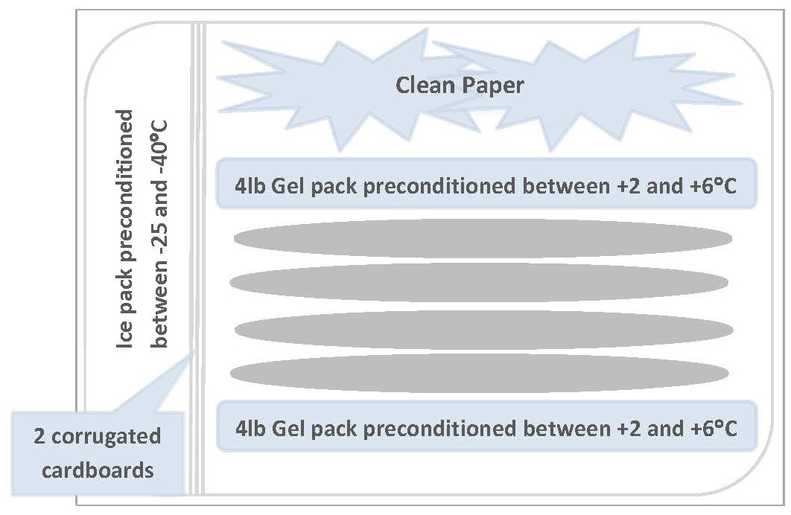

APPENDIX A - PACKING CONFIGURATION J82 SHIPPING CONTAINER (Refrigerated products)

- Ice/Gel packs need to be placed in individual zip lock plastic bags before being placed in shipping container
- Blood components or products are to be placed in a plastic over wrap bag prior to being placed in the shipping container

APPENDIX B: PACKING CONFIGURATION FOR E38 SHIPPING CONTAINERS (Room Temperature products)
E38 Shipping Container
1 to 6 PLT (20-24°C)
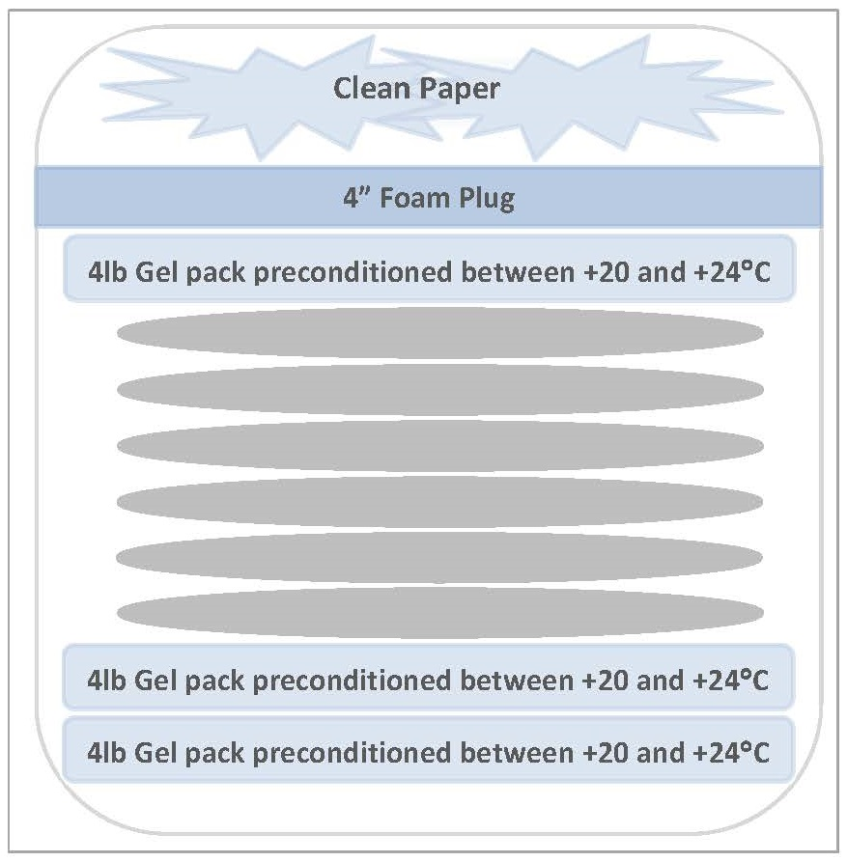

- Gel packs need to be placed in individual zip lock plastic bags before being placed in shipping container
- Blood components or products are to be placed in a plastic over wrap bag prior to being placed in the shipping container

